"Memorandum of Understanding"

**This Memorandum of understanding made on 27th February 2021, between “DZone India IT Solutions.’’ , and “Jaipur Mart ”.**

For Purpose of E-Commerce website development on laravel.

**Confidentiality Statement**

This proposal document is copyright protected and property of Jaipur Mart and is intended for internal use and documentation for development of Ecommerce Website (Laravel & HTML) only. This document contains commercially sensitive information and must not be made available to any individual or organization outside Dzone India IT Solutions. and ‘Mr. Ravineesh (Dzone India It Solutions)’ without written permissions from Ram Krishan Dargani (Owner Of Jaipur Mart). Any unauthorized disclosure may result in penalties and/or disciplinary action. ‘Mr. Ram Krishan Dargani’ will be the sole owner of all the rights pertaining to the intellectual property developed at the end of this contract and transfer of rights will be done after successful completion.

**What We Deliver**

* Customization
* Quality
* Satisfaction
* Dedication
* Positivity
* Interactivity
* Confidentiality

**SCOPE OF THE PROJECT**

* **Objective**
* **SCOPE**
* **Company Efficiency**
* **System Diagram**
* **Super Admin (Company Owner)**
* **Admin (No o f Employee)**
* **Customer**

Objective

The objective of this project is to study how the online selling website works and the process of the system followed by the users.

* To ensure customer satisfaction.
* To increase efficiency and improve services provided to the customers through better application of technology.
* It is designed to increase efficiency, save money and time.
* It shows the correct menu and enable the customers to order items that are available.
* To avoid long queues at the counter.
* To accommodate huge amount of orders at a time
* To improve the communication between the client and the server

Scope

We believe that online selling website will become even more popular in the future for the obvious reason that they save users, time and money by listing the product and minimum cost with latest design.

### Economy feasibility:

We have estimated that the cost for the development of this website will be minimum which will benefits the developers.

Design Diagram (Customer)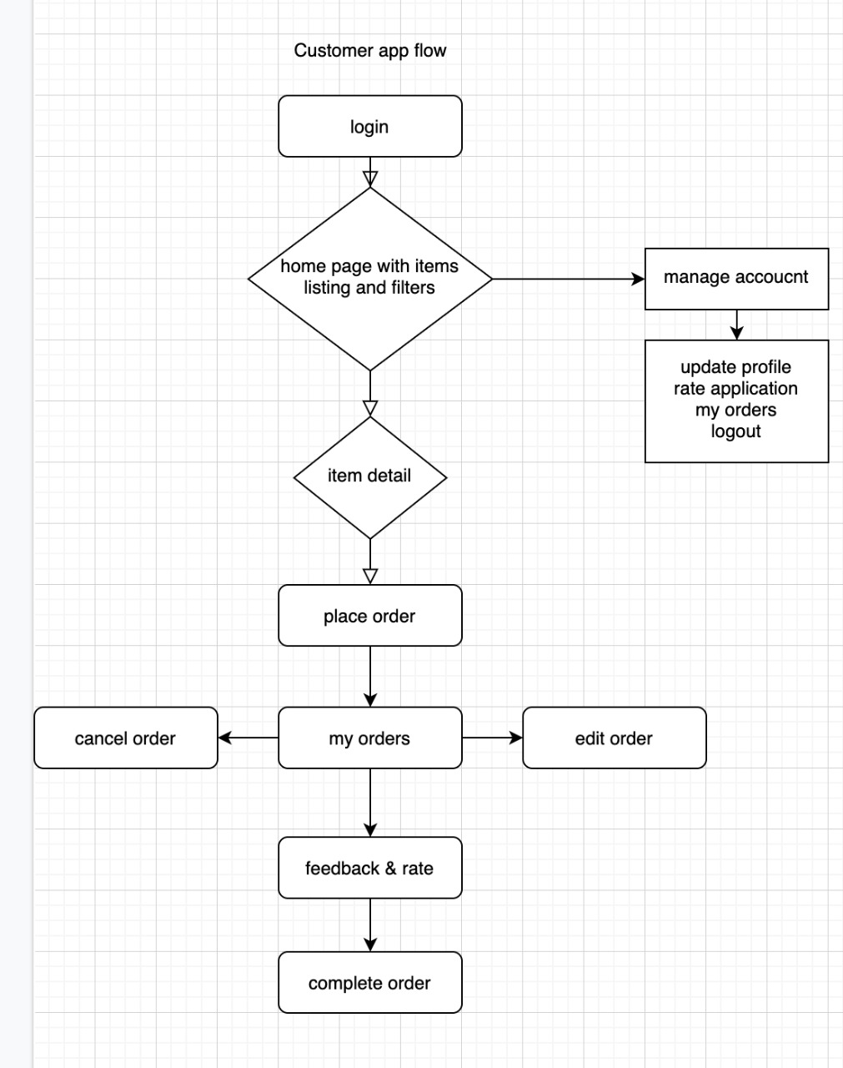

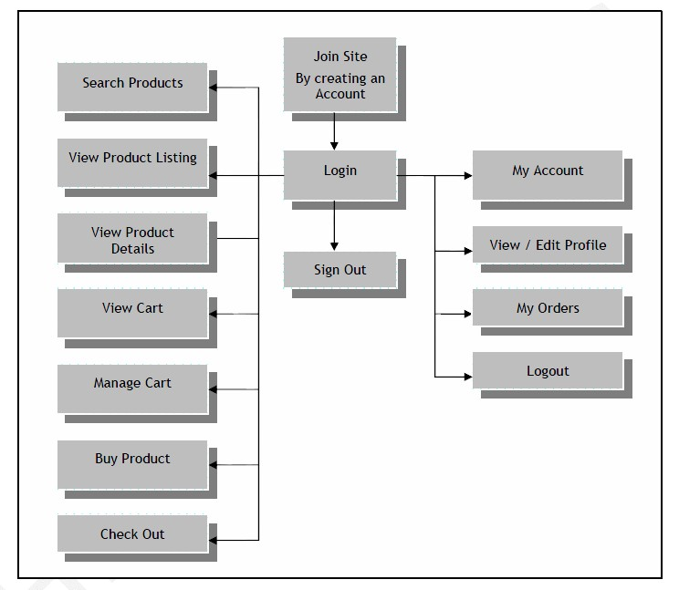

**Super Admin (Owner)**

* Login in panel through secure email and password
* Dashboard (Short Summery will be shown)
* Admin Manager
* Add (name, email, phone, password, status, image)
* Set Permission to access page/functions
* Listing (simple listing and filter)
* Edit
* Detailed View
* Change Password
* Delete (soft delete)
* Change Status (active/inactive)
* Product Manager
* Add (name, detail, price, status, image)
* Listing (simple listing and filter)
* Product Category Manager
* Product Sub-Category Manager
* Menu setting
* Multiple Color wise Product upload
* Related Product Setting
* Home page Product Setting (Best Seller, New Arrivals, Trending Product, Look Book, ETC.....)
* Product Discount Manager
* Product Discount Date Wise/Festival wise
* Edit
* Detailed View
* Delete (soft delete)
* Product images
* Rating and reviews
* Price details with choose quantity option
* Product gallery
* Product description Customer reviews
* Multiple Brands & Categories listings
* Unlimited Products listing
* Related Products listing
* Users wish list
* Add products to a single category or multiple categories
* Color Manager
* Size Manager
* Product Type Manager
* Fabric Type Manager
* Pattern Type Manager,
* Material Manager
* Pocket Type Manager
* Brand Type/Name Manager
* Tax Manager
* Change Status (active/inactive)
* Dynamic Brand Manager
* Create brand (jewellery, bed sheet, shoes...)
* Create Attribute
* Active/Inactive brand
* Edit Brand
* Map Attribute
* Coupon/Discount Manager
* Create and manage discount codes
* Add discount codes to categories, brand or products
* Coupon for new User
* No Of Coupon applied for Existing User
* Set and manage dates code is active
* Single Date wise Coupon
* Multiple date wise coupon and discount
* Category wise coupon apply
* Sub-Category wise coupon apply
* child Category wise coupon apply
* Product wise Coupon apply
* Brand wise Coupon apply
* Set minimum and maximum quantity requirements for discount codes
* Set number of times code can be used before automatically becoming
* Active/inactive Coupon

* Customer Manager
* Listing (simple listing and filter)
* Edit
* Detailed View
* Change Password
* Delete (soft delete)
* Change Status (active/inactive)
* Wallet Update (add/edit/delete)
* Customer Order Manager
* Listing (simple listing and filter)
* Detailed View
* Past order detail view
* Current Order detail view
* Cancelled Order detail view
* Custom Reports Manager (Exports in Excel and Pdf)
* Interactive administrative dashboard with charts and statistics
* Revenue Report
* Orders Report
* Products Report
* Categories Report
* Coupons Report
* Taxes Report
* Stock Report
* Customers Report
* Reports will be generated and downloaded by excel,(single date wise, multiple date wise, month wise, year wise)
* Wallet Manager
* Add Amount
* Delete Amount
* Edit Amount
* Active/Inactive Wallet
* wallet access Permission (Y/N)
* Permission For next purchase with wallet deduction
* Referral Manager
* user wise unique code
* backend permission
* update referral value
* edit referral
* delete referral
* Country wise Currency Manager (Paid Api)
* Google Geo api implantation
* separate currency will show
* country wise price show
* Price update
* change currency value
* Page Manager
* Add
* Listing
* Edit
* Detailed View
* Delete (soft delete)
* Change Status (active/inactive)
* Feedback Manager
* Listing (simple listing and filter)
* Detailed View
* Delete (soft delete)
* Change Status (active/inactive)
* Manage Profile
* Edit/Update
* Change Image
* Detailed View
* Change Password
* Log Out

**Admin**

* Login in panel through secure email and password
* Dashboard (Short Summery will be shown)
* **Product Manager**
* Add (name, detail, price, status, image)
* Listing (simple listing and filter)
* Product Category Manager
* Product Sub-Category Manager
* Menu setting
* Add currency wise price
* Multiple Color wise Product upload
* Related Product Setting
* Home page Product Setting (Best Seller, New Arrivals, Trending Product, Look Book, ETC.....)
* Product Discount Manager
* Product Discount Date Wise/Festival wise
* Edit
* Detailed View
* Delete (soft delete)
* Product images
* Rating and reviews
* Price details with choose quantity option
* Product gallery
* Product description Customer reviews
* Unlimited Products listing
* Related Products listing
* Users wish list
* Add products to a single category or multiple categories
* Color Manager
* Size Manager
* Product Type Manager
* Fabric Type Manager
* Pattern Type Manager,
* Material Manager
* Pocket Type Manager
* Brand Type/Name Manager
* Tax Manager
* Change Status (active/inactive)
* Dynamic Attribute Manager
* Add
* Listing
* Edit
* Detailed View
* Delete (soft delete)
* Change Status (active/inactive)
* Color Manager
* Size Manager
* Product Type Manager
* Fabric Type Manager
* Pattern Type Manager,
* Material Manager
* Pocket Type Manager
* Brand Type/Name Manager
* Tax Manager
* Customer Manager
* Listing (simple listing and filter)
* Edit
* Detailed View
* Change Password
* Delete (soft delete)
* Change Status (active/inactive)
* Discount/Coupon Manager
* Add discount codes to categories, brand or products
* Create and manage discount codes
* Coupon for new User
* Create and manage discount codes
* No Of Coupon applied for Existing User
* Set and manage dates code is active
* Single Date wise Coupon
* Multiple date wise coupon and discount
* Set minimum and maximum quantity requirements for discount codes
* Set number of times code can be used before automatically becoming inactive
* Customer Order Manager
* Listing (simple listing and filter)
* Detailed View
* Past order detail view
* Current Order detail view
* Cancelled Order detail view
* Return/Refund Management
* order history management
* Invoice management

* Custom Reports Manager (Exports in Excel)
* Interactive administrative dashboard with charts and statistics
* Revenue Report
* Orders Report
* Products Report
* Categories Report
* Coupons Report
* Taxes Report
* Stock Report
* Customers Report

Reports will be generated and downloaded by excel,(single date wise, multiple date wise, month wise, year wise)

* Referral Manager
* user wise unique code
* backend permission
* Custom Notification Manager
* bulk/single Notification via email
* bulk/single Notification via whats app (paid api)
* new arrivals product notification filter wise user
* Page Manager
* Add
* Listing
* Edit
* Detailed View
* Delete (soft delete)
* Change Status (active/inactive)
* Manage Profile
* Edit/Update
* Change Image
* Detailed View
* Change Password
* Feedback Manager
* Listing (simple listing and filter)
* Detailed View
* Delete (soft delete)
* Change Status (active/inactive)
* Log Out
* **Advance Requirements**
* **First** - wholesale has 3 stores which has different pricing for each store and these stores country specific

1. India Store – For India Customers
2. USA Store – For USA, UK, Australia, Canada, Malaysia, Spain, etc and few more countries
3. UK Store – Rest of the world

We can change the country from one store to another through backend. Product Prices are different for each store and prices shown in country is as per store .

* **Second**- This is a B2B website, customers add multiple products in their cart and cart can be viewed only if a customer is login to his account (To view cart customer first login or create new account) Once customer login , we can see customers cart from backend.
* **Third** – Minimum order value should be Rs 2000 for India and USD 100 for Out of India
* **Fourth** – Shipping is automatically applied as per cart weight at the time of checkout (Predefined rates Given) and free shipping on specific amount (For eg 150 USD, we can change it as per our requirement)
* **Fifth** – All products have available quantity Mentioned and as they get sold it is updated automatically on frontend & Backend and once all sold it gets hidden from website as well as from all customers cart.
* **Sixth** – Cart Gets automatically updated if any products in cart is out of stock from website.
* **Seventh** – We have 4 Payment Gateways on website – 2 for India (Razor Pay & Paytm ) and 2 for out of India (Paypal & RazorPay)
* **Eighth** – Rewards Points Extension (Mirasvit) in wallet credit
* **Ninth** – Add multiple products to Cart on category Page extension (BSS Commerce)
* **Tenth** – Cart can be downloaded in PDF
* **Eleventh** – After order , Product Images and Description of order can be downloaded from customers account
* **Twelfth** – Order Confirmation mails, Order Shipped emails, Abandoned Cart Emails, New Arrivals Emails, Promotional Emails,
* **Thirteenth** – Push Notifications required
* **Forteenth** – Image Share on whatsapp (not sure)
* **Fifteenth** – If any order in pending payment, it gets automatically cancelled after 15 minutes and all products restored back in inventory as well as added back in customers cart .
* **Sixteenth** – Products added by customer in cart should be visible in backend in Abandoned cart.
* Seventhenth -

This is a B2B website and Make Sure the speed of app must be excellent . There should be no lag in page load or cart load. (Right now after adding 150 products to cart , cart page doesn't load)

* abundant cart report after login
* product will be added after login/signup

**Customer**

* website View
* Login Screen
* Signup process (approval basis)
* login id/pass through email (admin panel)
* approval request can be approved or rejected by admin
* Gallery image
* My Account complete functionality
* Recently viewed product
* Notification on Gmail and Mobile
* Wallet Amount Redemption (Virtual Money)
* Search items based on (item name, Sku no., Price, latest collection)
* Detailed view of item
* Place order
* My Orders
* Edit order
* Cancel order
* Past orders (complete orders history)
* Order detailed view
* Manage Profile
* Edit/Update
* Change Image
* Detailed View
* Change Password
* Update Address
* Log out
* **Project Exclusions (Things that are not covered in the cost)**
* Hosting/server cost
* SSL
* Domain
* Any third party API/plug-in/extension if used during the development
* **Post Development Support**

We provide 60-day of free support and maintenance for any errors/bugs that might come up during the live user experience. We will try to solve/fix the errors/bugs in minimum turnaround time. The support time starts after final delivery of the project to the client. After the support time period ends, maintenance can be availed on chargeable basis

* Following things will be covered in the maintenance
* Bug/error fixing
* Design modifications/design issues
* Feature extension
* Functionality upgrades
* Server management
* **Project Exclusions (Things that are not covered in the cost)**
* Hosting/server cost
* SSL
* Domain
* Any third party API/plug-in/extension if used during the development
* **General Terms**
* The project amount is Exclusive of all taxes
* We work throughout the month except 2nd Saturday and Sundays
* Our team will communicate with you through E-mail or Whats App or Skype or Zoom or any other channel of your choice
* All third party API is chargeable
* All Payment should be in Favor of Dzone India IT Solutions
* We Accept Payment through NEFT, RTGS, DD, and Cheque Only.

**Website Development Cost**

|  |  |  |  |
| --- | --- | --- | --- |
| S.NO  . | Technology Web (PHP Laravel) | Time Schedule | Amount  Price |
| 1. | Admin Panel : Super Admin, Admin, Customer  Front End Implementation | 40-60 Days |  |
| 2. | Testing and Deployment | 20 Days |  |
| 3. | Total Estimation | 60-90 Days  Demo on Development Server | 2,50,000 |

**Milestone-based payment schedule**

|  |  |  |
| --- | --- | --- |
| **Milestone**  **.** | **Schedule** | **Amount** |
| Milestone 1 | Project kick-off amount so that we can start-off with the work | 30% |
| Milestone 2 | After UI/Front-end design is completed and Admin 50% Completed | 20% |
| Milestone 3 | At the beta-release of the site | 30% |
| Milestone 4 | After the final testing but before site goes live | 20% |

**Resources to be Utilized**

|  |  |
| --- | --- |
| Project Lead | 1 |
| Database Developer | 1 |
| Laravel Developer | 1 |
| HTML Front end Designer | 1 |

**Testing & QA**

|  |  |
| --- | --- |
| Technology Stack Software | Product |
| Database Server | MYSQL |
| Operating system | WINDOW,MAC |
| Development Environment | HTML, PHP LARAVEL FRAMEWORK, JS and jQuery, BOOTSTRAP |

**BROWSER COMPATIBILITY**

|  |
| --- |
| Supported Browser |
| Microsoft Edge Latest Version |
| Firefox Latest Version |
| Google Chrome Latest Version |